Name: Khatuna Jannat Mim

Roll: 01-026-023

Topic: Data report on the rate of climate change caused by chemicals in many countries of the world analyzing the data.

**Global Climate Change Report: Chemical Emissions and Impact**

**Introduction**

This report analyzes greenhouse gas emissions across various countries, highlighting the major contributing chemicals, emission targets, current policies, and adaptation strategies. The data underscores the urgent need for global cooperation and effective strategies to mitigate climate change.

Key Findings

**01.Major Greenhouse Gases Contributing to Climate Change**

* Carbon Dioxide (CO2) is the predominant greenhouse gas emitted by nearly all countries.
* Methane (CH4) and Nitrous Oxide (NO2) are also significant contributors, particularly in agricultural and waste management sectors.

1. **Global Emission Levels**

* China (10,065 Mt CO2e) and the USA (5,416 Mt CO2e) are the highest emitters.
* Countries like Bangladesh (200 Mt CO2e) and Bhutan (10 Mt CO2e) have lower emissions but face high vulnerability to climate impacts.

1. **Emission Reduction Target**

* Many countries aim for substantial reductions by 2030, with targets ranging from 5% (Bangladesh) to 100% (Iceland).
* Developed nations, such as the USA and Canada, target around 50% reductions, while developing countries often set lower targets due to economic constraints.

**04.Current Policies and Legislation**

* A diverse range of policies exists, from renewable energy investments (e.g., Argentina, Mexico) to emission trading schemes (e.g., Armenia).
* Countries like Germany and Denmark emphasize renewable energy and energy efficiency, reflecting strong public support for climate initiatives.

**05.Yearly Change in Emissions**

* Yearly emission changes vary widely, with some countries like Germany showing a significant decrease (-6.2%) while others, such as China, report a small increase (1.4%).
* Developing nations often exhibit negative trends due to economic growth and industrialization pressures.

**06.Vulnerability to Climate Change**

* Countries in regions like South Asia (e.g., Bangladesh, India) and Africa (e.g., Nigeria, Ethiopia) are classified as highly vulnerable due to their geography and socio-economic conditions.
* Adaptation strategies focus on resilience-building through sustainable practices and infrastructure improvements.

**07.Adaptation Strategies**

* Countries are employing various adaptation strategies, including:
* Coastal Management (Bangladesh)
* Reforestation (Indonesia, Ethiopia)
* Renewable Energy Investments (South Africa, Mexico)
* Water Management (Pakistan, Somalia)

**08.Comparative Analysis**

* High emitters like China and the USA face greater scrutiny and pressure to implement immediate and effective reductions.
* Lower emitters often struggle with development needs and may require international support for sustainable growth.

**09.Developed vs. Developing Nations**

* Developed nations generally have more resources to invest in clean technologies and can set more ambitious targets.
* Developing nations, while contributing less to total emissions, may need tailored strategies that consider their developmental contexts.

**The Excel Data sheet:**

**Comprehensive Report on Mitigating Climate Change and Reducing Greenhouse Gas Emissions**

**Introduction**

Addressing climate change requires a multifaceted approach that integrates technological innovation, policy reform, community engagement, and international collaboration. This report outlines strategies for reducing greenhouse gas emissions, focusing on actionable steps that countries can take to mitigate the impacts of climate change effectively.

Key Strategies for Mitigation

Transition to Renewable Energy

**01.Investment in Solar and Wind Power:**

* Countries should increase investments in renewable energy sources. For instance, solar panels and wind turbines can significantly reduce reliance on fossil fuels.
* Incentives for Clean Energy: Governments can provide tax breaks and subsidies for businesses and homeowners to install renewable energy systems.

**02.Enhancing Energy Efficiency**

* Implementing Energy Standards: Stricter efficiency standards for buildings, appliances, and vehicles can lead to substantial reductions in energy consumption.
* Smart Grids: Developing smart electrical grids can optimize energy distribution, reducing waste and enhancing the use of renewable sources.

**03.Sustainable Transportation**

* Public Transportation Infrastructure: Investing in efficient public transport systems can reduce reliance on personal vehicles, thus lowering emissions.
* Electrification of Transport: Promoting electric vehicles (EVs) through subsidies and charging infrastructure can significantly cut down transportation-related emissions.

**04.Agricultural Practices**

* Sustainable Agriculture: Transitioning to sustainable farming practices such as crop rotation, organic farming, and agroforestry can reduce emissions from the agriculture sector.
* Methane Reduction Techniques: Implementing techniques like anaerobic digestion can help capture methane emissions from livestock waste.

**05.Waste Management**

* Recycling and Composting: Enhancing recycling programs and composting organic waste can reduce landfill emissions and promote resource efficiency.
* Waste-to-Energy Technologies: Investing in technologies that convert waste to energy can provide a dual benefit of waste reduction and energy production.

**06.Forestry and Land Use**

* Reforestation and Afforestation: Initiatives aimed at restoring forests and planting new trees can absorb CO2 from the atmosphere.
* Sustainable Land Management: Adopting practices that prevent deforestation and promote biodiversity can protect carbon sinks.

**07.Policy and Legislation**

* Implementing Carbon Pricing: Establishing a carbon tax or cap-and-trade system can incentivize emissions reductions by placing a financial cost on carbon emissions.
* International Agreements: Countries should commit to international climate agreements (e.g., Paris Agreement) that set legally binding emissions targets.

**08.Public Awareness and Education**

* Community Engagement: Programs that educate the public on sustainability practices can encourage individual actions that contribute to emissions reductions.
* Corporate Responsibility: Encouraging businesses to adopt sustainability practices can lead to significant reductions in their carbon footprints.

**09.Challenges and Barriers**

* Economic Constraints: Developing countries may lack the financial resources to invest in new technologies or infrastructure.
* Political Will: There can be resistance from policymakers influenced by fossil fuel industries.
* Public Perception: Misinformation and lack of awareness can hinder public support for climate initiatives.

**Conclusion**

Mitigating climate change and reducing greenhouse gas emissions require a holistic approach that encompasses technology, policy, and community involvement. By implementing the strategies outlined above, countries can make significant progress toward achieving their emissions reduction targets.

**Recommendations for Implementation**

1. Develop National Action Plans: Countries should create detailed action plans tailored to their unique circumstances, specifying how they will achieve emissions reductions.
2. Foster International Collaboration: Sharing knowledge and resources among nations can enhance efforts to combat climate change effectively.
3. Monitor and Report Progress: Establishing systems to track emissions reductions and the effectiveness of various strategies can ensure accountability and continuous improvement.
4. 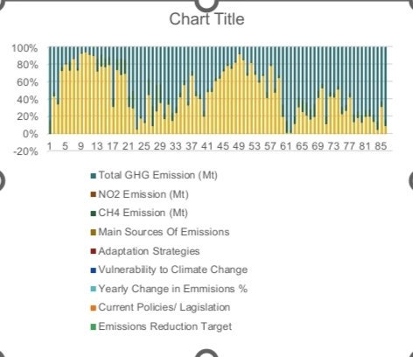By committing to these actions, the global community can work collectively toward a sustainable future, significantly mitigating the impacts of climate change

**Pivot table 01:**

**Data Report: Yearly Change in Emissions by Country**

**Overview**

This report presents the yearly percentage change in emissions for various countries. The data reflects both decreases and increases in emissions, highlighting trends that are significant for understanding global environmental impacts.

**Key Findings**

**Countries with Significant Decreases in Emissions:**

* Thailand: -10.00%
* Argentina: -8.00%
* Philippines: -8.00%
* Germany: -6.20%
* Iceland: -6.00%
* Colombia: -6.00%
* Malaysia: -6.00%

**Countries with Moderate Decreases:**

* Denmark: -5.00%
* Portugal: -5.00%
* Norway: -4.00%
* Austria: -4.00%
* New Zealand: -4.00%
* South Africa: -4.00%
* Czech Republic: -3.00%
* Canada: -3.50%
* Estonia: -3.50%

**Countries with Minor Decreases:**

Countries such as Bulgaria (-1.80%), Bahrain (-1.80%), and Egypt (-1.80%) show slight reductions in emissions.

**Countries with Stable or Increased Emissions:**

* Ethiopia: +5.00%
* Brasil: +2.00%
* China: +1.40%
* Ghana: +1.50%
* India: +1.00%
* South Korea: +2.00%

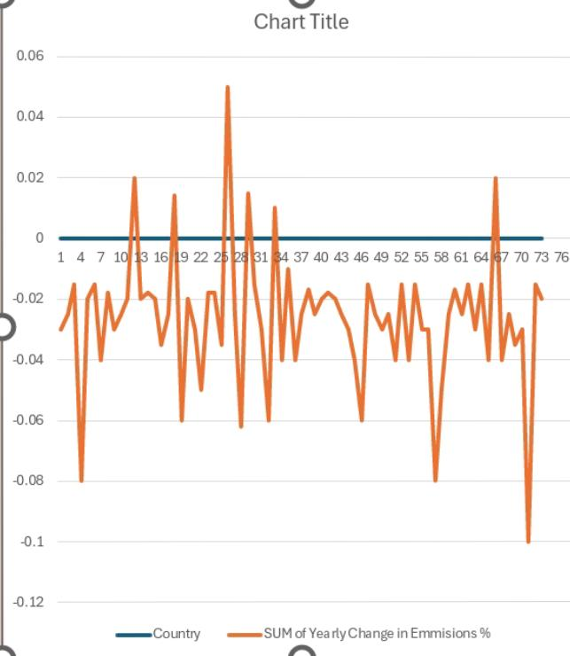

**Pivot table 02:**

**Data Report on Carbon Dioxide Emissions**

**Overview:**

This report analyzes greenhouse gas emissions (measured in metric tons of CO2 equivalent) for various countries. The data highlights the countries with the highest and lowest emissions.

Key Findings

**Country with the Highest Emissions**

* Country: Argentina
* Emissions: 20,130 Mt CO2 e

Significance: Argentina has the highest greenhouse gas emissions among the countries listed. This could be attributed to various factors, including industrial activities, agriculture, and energy production.

**Country with the Lowest Emissions**

* Country: Iceland
* Emissions: 10 Mt CO2 e

Significance: Iceland exhibits the lowest emissions, likely due to its reliance on renewable energy sources, including geothermal and hydroelectric power, and a smaller population and industrial base.

**Comparative Analysis**

The emissions data range significantly, with Argentina’s emissions vastly exceeding those of Iceland.

**Other notable high-emission countries include:**

* United States: 5,416 Mt CO2 e
* China: 10,065 Mt CO2 e
* India: 2,654 Mt CO2 e

Conversely, several countries have low emissions, including:

Kyrgyzstan: 30 Mt CO2 e

Brunei: 30 Mt CO2 e

Norway: 30 Mt CO2 e

**Conclusion**

The analysis indicates significant disparities in greenhouse gas emissions across countries. Argentina stands out as a major emitter, while Iceland exemplifies low emissions through sustainable energy practices. Understanding these patterns is crucial for global climate policy and efforts to reduce emissions.

**Recommendations**

* For High Emitters: Focus on reducing emissions through cleaner technologies and policies aimed at sustainability.
* For Low Emitters: Share best practices and strategies with other countries to promote sustainable development and energy usage.

This report can serve as a foundation for further discussions on environmental policies and emission reduction strategies.

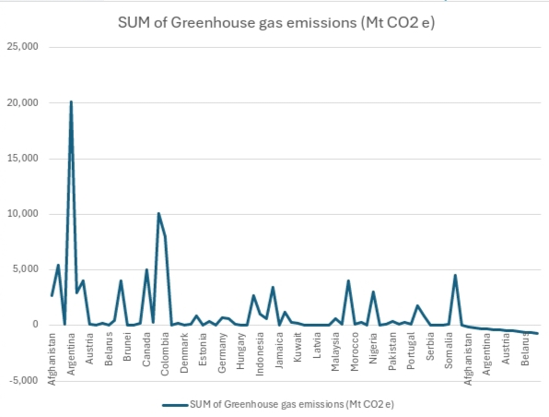

**Conclusion and Recommendations**

The data underscores the urgent need for global collaboration and significant reductions ingreenhouse gas emissions. Countries with the highest emissions must prioritize cleaner technologies and sustainable practices. Key recommendations include:

* Enhanced International Cooperation: Collaborate on technology sharing and funding for sustainable initiatives.
* Investment in Renewable Energy: Focus on transitioning from fossil fuels to renewable energy sources.
* Strengthening Adaptation Efforts: Increase funding and resources for countries vulnerable to climate impacts.

The report highlights the complexity of climate change and the critical need for a unified global response to mitigate its effects effectively. Further detailed analyses can be conducted to tailor strategies for specific regions or sectors.